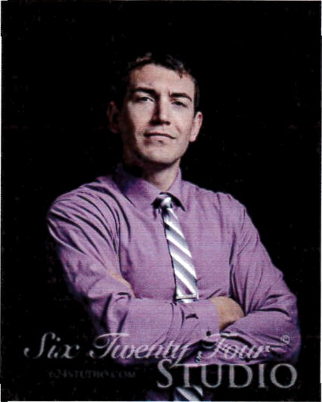

Joshua Alan Rossnagel
External Operations Supervisor
East Carolina University Parking and Transportation
305 E 10" Street, Greenville NC 27858

To whom it may concern,

I would like to put forth myself as a nominee for the Carolinas Parking Association Board of Directors. I have a long and diverse history with ECU Parking. I began my career as a Parking Enforcement Officer where I learned the methods behind influencing behavior and compliance through enforcement. After two years in enforcement I had a brief tenure as an assistant cashier in the administration section. That position gave me an appreciation for customer service responsibilities, financial/audit obligations and the stress that our front desk staff have daily. Next, I spent many years working as an external maintenance technician where I learned ADA parking codes, parking layouts, short-term and long-term maintenance planning, monetary collections, and PARCS maintenance. While in this position our department established a formal Event Coordinator position which I became the first to fill. As the Event Coordinator I planned small and large-scale events, met with campus administrators, and managed construction project parking for all campus. In this position I learned time management skills, interpersonal skills, and the monumental amount of effort that goes into running a university. Eventually, the opportunity arose for me to return to the External Operations Maintenance section but this time as the supervisor. While serving as the External Operations Supervisor I absorbed the Transportation Demand and Bike Programs sections of our department as well. Within the University I also serve on the Sustainability Committee, NCAPPA Planning Committee, and the Emergency Management Committee.
Currently, I am pursuing a degree in Construction Management and my CAPP credentials. Having filled such a broad spectrum of positions in the parking community has given me an insight into the difficulties and potentials each area possesses. I believe my experience will be an asset to the CPA Board and It would be an honor to serve with the other board members.

