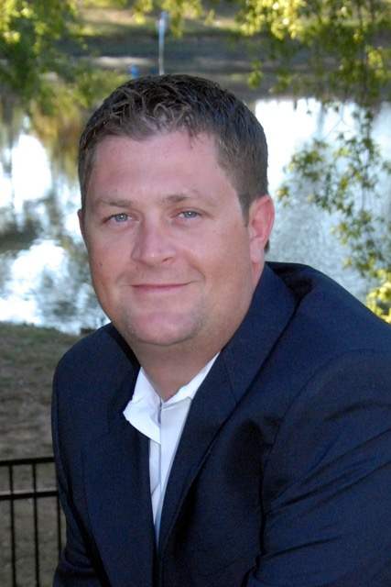

Currently, I operate MobileNOW! LLC from the Vice President of Operations seat with our home base in Charlotte, NC. I report to our parent organization and the few MobileNOW! team members report to me. I am responsible for all things MobileNOW! including budgeting, sales, implementation, Customer Support and Client Services, as well as vendor relationship management and asset management.

MobileNOW! is a mobile payment platform for the parking business offering Pay on Demand mobile payment services as well as electronic permitting and electronic validations.

My start in parking began in the late 90’s when I joined an operator in Charlotte, NC as parking enforcement employee while I was finishing my Business Degree at University of North Carolina at Charlotte. I stayed with Preferred Parking for around 10 years working my way up to a director position before I left to pursue other avenues in the industry.

After leaving, I joined a company named QuickPay as Implementation Manager and stayed with them for around 4 years. With QuickPay, I was responsible for all deployments of our platform.

I have now been with MobileNOW! for over 5 years and have been running the organization for a little over a year.

With approximately 20years in the industry covering many facets of the industry, I believe that I would be a valuable asset to the CPMA board.

