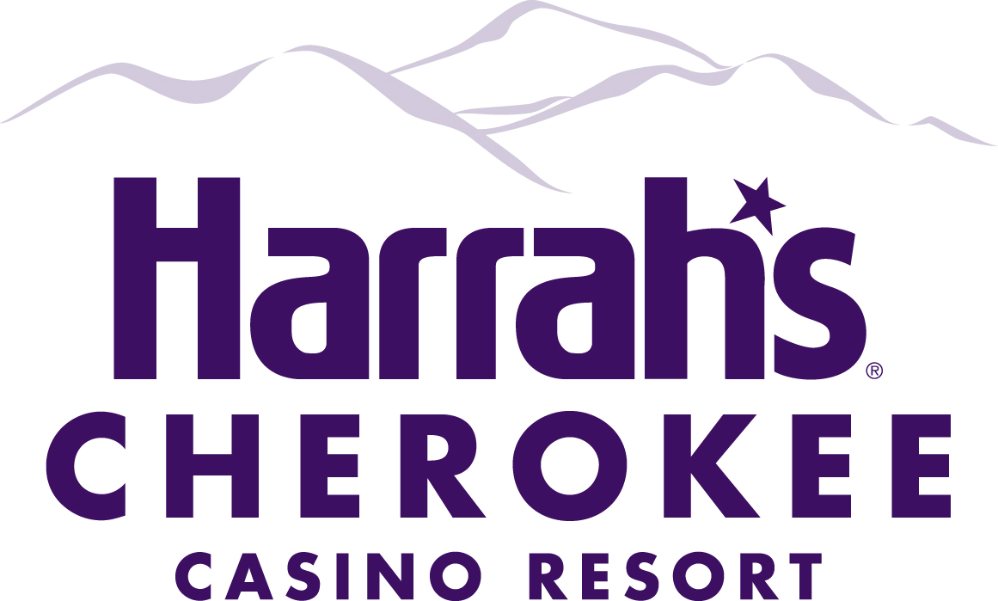

Exhibitor Information Packet

Please note the following regulations are currently in place for all exhibitors:

- Vendors must comply with Caesars’ health and safety protocols and
applicable operating standards as communicated to vendors.
- Vendors’ staff must sanitize hands upon arrival and wear appropriate face
masks. Vendors must comply with the social distancing regulations which require all guests to maintain a distance of 6ft apart.

The following information has been provided to assist you in understanding Harrah’s Cherokee Resort Casino policies and procedures for exhibitors in our Hotel Conference Center and Event Center. We hope that you will take a moment to read this over to ensure that your event is a successful one. We appreciate your business and hope you will return again and again.

- No firearms are allowed in our facility

- Additional charges apply for electricity or telephone service. All requests for service must be submitted to the Catering/Convention Services Department in writing and accompanied by payment, a minimum of two weeks prior to the event. Please see attached electrical and telephone order forms.

- No shipping packages will be received earlier than three days prior to the event. All packages must be addressed to:

Harrah’s Cherokee Casino Resort
ATTN: Catering/Convention Coordinator -Jennifer Rose
(Include Convention/Event Name & Date of Event)
777 Casino Drive
Cherokee, NC 28719

Package must note the convention event and be marked with “Sample” or “Demo”, regardless of whether the materials are brochures or promotional items. All shipping orders will be returned to sender if they arrive any sooner or are improperly labeled.

- All return shipments must be clearly labeled and you must reference your shipper account numbers on the package. You can drop them off at the Warehouse on the 1st floor of the Casino Parking Garage or pay the $10 fee to have your items picked-up from the convention space and delivered to the warehouse. It is best if you bring your own labels with you, as they will already have your account number on them. If you are going to issue a call tag, please inform the convention sales office prior to calling.

- Harrah’s Cherokee Resort Casino is not liable for any lost or damaged shipping packages prior to arrival or after departure from the facility.

- All shipped packages will be held in a secure area and will be signed in and out by the exhibitor’s pre-selected representative.

- All booth assignments will be made by your “event coordinator”

- All exhibitors are responsible for securing their own materials during the show and during “down times”.

- No adhesive is to be used on the Conference Center walls, and confetti is not allowed in the Conference Center. (3M Command Strips are acceptable).

Load-In and Load-Out Procedures

Hotel Conference Center - All exhibitors bringing equipment or materials associated with a convention event should enter the Conference Center area of the hotel through the three floor hotel-parking garage. If parking is available on Level 3, this would be most convenient for you. If you cannot park on Level 3 and must use the guest elevator, the maximum weight limit is 3500 lbs and the door dimensions are 3’5” X 6’10”, and the elevator dimensions are 6’7” wide X 5’3” deep X 7’3” tall. Please do not park in front of the entrance doors to unload or load.

Event Center – All exhibitors bringing equipment or materials associated with a convention event should enter the casino at the West Porte-Cochere then take the elevator to the 2nd floor (Main Floor Event Center). Vehicle can be parked at this location for unloading and loading but should be moved as soon as possible. If items are too large for guest elevators, Event Center loading docks & freight elevator can be utilized with prior approval by Harrah’s Cherokee Resort Casino staff. NOTE: No one under the age of 21 is allowed on the Casino Floor

Due to gaming regulations, the Service Corridors and Service Elevator are accessible only to Harrah’s Cherokee Resort Casino staff and licensed vendors with badges. Items requiring the service elevator must be prearranged by contacting the your catering/convention services department. The Event Center freight elevator door dimensions are 10’ x 9’, the elevator measures 10’ wide X 19’ deep X 9’ tall, and the maximum weight is 4500 lbs.

The Catering/Convention Services Department will need a list of all participating exhibitors and the name of the person acting as the companies’ representative. This list should be submitted at least two weeks prior to event. Depending on the number of exhibitors, it may become necessary to designate load-in and load-out times. If we deem this necessary, the convention sales office will contact the “event coordinator” with a time schedule.

All designated company representatives must provide a photo ID to sign out any shipped packages from our secured staging area.

.

Electrical Service Order Form

In order for us to properly service all exhibitors, this electrical service order form must be completed and returned to Harrah’s Cherokee Resort Casino fourteen (14) days prior to date of event. Check Payment or Credit Card Authorization must be included with this order form. Orders not received prior to set up day or sent without payment are subject to $75 same day set up fee and the requested electrical power may be not available.

Please complete the following:

Convention Name ___________________ Convention Date __________________

Exhibitor Name ______________________ Booth Number ___________________

Address ___________________________ Telephone _______________________

City _______________________ State ________ Zip Code ______________

Email address: _______________________ Number of units requiring power _____

Authorized Signature __________________________

Print Name Here ______________________________

Standard Power is 20 amp/120 volt/single phase power. This is the same power that is typically in most homes. Each power line has 3-3 prong outlets. The cost is $35 per day for each standard circuit. A line is needed for each piece of equipment. Additional equipment (i.e. Extension Cords, Power Strip) are included in cost.

*Number of lines required ______ @ $35 x Number of Days of show ______ = $________payment due to Harrah’s Cherokee Resort Casino

Special Electrical Service is 208 volt/single or three phase power. This is the type of power needed for larger pieces of equipment. The cost for Special Electrical Service is $125 per day for each line. A line is needed for each piece of equipment.

*Number of lines required ______ @ $125 x Number of Days of show ______ = $________payment due to Harrah’s Cherokee Resort Casino

Type of Service: Standard _____ Special ______

Method of Payment: Check _____ Credit Card ______* please complete enclosed credit card authorization

Be advised that all exhibit equipment and materials must be removed from exhibit area by midnight of teardown day. Materials left behind will be discarded.

Telephone Service Order Form

In order for us to properly service all exhibitors, this Telephone Service Order form must be completed and returned to Harrah’s Cherokee Resort Casino fourteen (14) days prior to date of event. Check Payment or Credit Card Authorization must be included with this order form. Orders not received prior to set up day or sent without payment are subject to $75 same day set up fee and the requested telephone service may be not available.

Please complete the following:

Convention Name ___________________ Convention Date __________________

Exhibitor Name ______________________ Booth Number ___________________

Address ___________________________ Telephone _______________________

City _______________________ State ________ Zip Code ______________

Email address: _______________________

Authorized Signature __________________________

Print Name Here ______________________________

All telephone lines are analog and you must dial “9” to obtain an outside line. Lines are only set up for local calls and “800” telephone numbers. If a long distance line is needed it is important that you check that box. We will need a Credit Card guarantee for any long distance request to be charged at the end of function. Each line is $55 per day.

*Number of lines required ______ @ $55 x Number of Days of show ______ = $________payment due to Harrah’s Cherokee Resort Casino

Type of Service Requested: Line Only _____ Phone _____ Speaker _____

Internet _____ Long Distance Service _____

Be advised that all exhibit equipment and materials must be removed from exhibit area by midnight of teardown day. Materials left behind will be discarded.

CREDIT CARD AUTHORIZATION FORM

Today’s Date: ___________________

Group Contact: _______________________________________

Address: _______________________________________

_______________________________________

_______________________________________

Group Name: _______________________________________

Group Dates: _______________________________________

Email: _______________________________________

Ph: ___________________

Along with a photocopy of the front of credit card, please supply the following information and signatures, then fax to (866)833-1492

This is authorization for Harrah’s Cherokee Resort Casino to charge the following credit card for

$ Electricity or Phone Payment upon receipt of this form. Any additional services or products added during the event will be approved by the card holder and charged to this card at the end of the event.

Credit Card Type:

Credit Card Number:

Expiration Date:

Card Holder’s Name:

Authorized Signature: ______________________________________

Please include copy of the front of credit card.

